Father Anselmo Landoy
780-961-3613

Secretary
Pat Letourneau
Ph. 780-961-3613
Fax: 780-961-3610
9:30-1:00 Wed. and Thurs.
parish@stemile.ca

Finance Committee
Malcolm MacDonell
780-961-3346
Bert Jodoin
780-921-3681

Safe Parish Committee
Guy and Debbie Charrois
780-221-8741 (Guy)
12th Sunday in Ordinary Time
June 20 juin, 2021
12ième dimanche du temps ordinaire

le 19 novembre 13, 2017

780-991-8741 (Deb)

Music Ministry
Joanne Pelletier
Michelle Evans
Pat Letourneau
Maria Weir
Kurtis Hauptman
Jim and Janice Baker

St. Emile Men of Service
Kurtis Hauptman
780-918-9006
klhauptman@hotmail.ca

Catholic Women’s League
Bernice Montpetit
President
780-961-2194
Mtg. every 4th Tuesday

Children’s Liturgy
Cassandra Ouellette
780-919-8738
Cancelled due to covid

The EDGE Youth Group -9+
Jolene Hennessy 780 405-1281
Chelsie Letourneau780-919-3888
Cancelled due to covid

PAROISSE
ST. EMILE
PARISH
5005 – 46 street
Box 90, Legal AB T0G 1L0

JESUS CALMS THE STORM
Welcome to all
new Parishioners

Donation Envelopes
If you would like to register for donation envelopes, please call the office.

Natural Family Planning
Jaclyn Sandmaier
780-893-5868
j.sandmaier@yahoo.ca

Liturgy Coordinator
Lorretta Chauvet
780-217-8392

Maintenance Committee
Bert Jodoin
780-288-1747

Young Women’s Book Study
Samantha Beier
780-903-2220
Cancelled due to covid

Church Environment/Décor
Cathy Proulx 780-961-4180
Pauline Prefontaine 780-868-4112

Baptism:
Contact the parish office for information and to register.

Sacramental Preparation for children
Kathy Kieser – 1st Reconciliation
and Baptism 780-206-6630
Lorretta Chauvet 780-217-8392
Ruth Schafers 780-961-3241
(Confirmation/1st Holy Communion)

Marriage/Wedding:
Please contact the office at least 6 months in advance of your wedding date.

Sacrament of the Sick:
Please call the office 961-3613 or
in urgent cases, if priest is absent, the nearest parish priest.

Funerals
Please make appointment with Father before other arrangements are made (780-961-3613)

Cemetery
Call Real Champagne
780-961-3850
780-717-3939

RCIA:
Rite of Christian Initiation for Adults
Call Parish Office

Altar Serving Facilitators
Jeremiah and Benjamin Evans
587-341-3398
Cancelled due to covid

Gospel Reflection: 12th SUNDAY IN ORDINARY TIME
The readings today are a reminder of who we are and whose we are. God answers Job after Job’s struggle to understand why tragedy has come into his life. Paul’s letter reminds us that God is still active, re-creating us and the world around us. Mark’s Gospel shows us disciples who are frightened by the weather: their boat that appears sturdy and capable when the waters are calm now appears so tiny and vulnerable. Once the disciples waken him, Jesus calms the storm and asks why they are afraid. In all these readings, we have very strong images that speak to us of trust and peace.
We find ourselves often getting swept up in the storms of life and this can be overwhelming. We can relate to Job and the disciples – we struggle with trusting God, and we easily get anxious. We wonder where God is as we face challenging circumstances.
“Peace! Be still!” Jesus is inviting us to trust him fully. Though we may be feeling uncertain or scared, God is letting us know God’s faithfulness is stronger than what we are feeling in any given moment. We are to trust God’s perspective rather than our own.
We always want to know why things are happening. Instead, let us ask God how these circumstances can help us grow in holiness.
(Living with Christ – Adriana Rerecich, Hamilton, ON)

__________________________________________________________________________________________________________________________________

GENERAL COLLECTION – June 13, 2021
General Collection - $1,318.00
Maintenance - $ 130.00
Thank you so much/un gros merci pour votre générosité!
______________________________________________________________________________________

RECONCILIATION – Please note that Father is available for confessions

anytime by appointment as well as 20 minutes prior to weekday and Sunday Masses.

_________________________________________________________________________________________________________________________________

COVID RESTRICTIONS – LOOKS LIKE WE’RE BACK UP TO 1/3
seating capacity so 1/3 of approx. 480+a few is 160 parishioners at each Mass. Praise the Lord!

++++ Father Anselmo has decided to continue having 2 Masses

every Sunday throughout the summer.

__________________________________________________________________________________________________________________________________
Father Anselmo goes to celebrate Mass in Vimy every Tuesday evening at 7:00 pm.
________________________________________________________________________________

GIFTS AT THE BACK OF THE CHURCH – Bernice Montpetit will gladly meet anyone (one on one) to shop the gift supplies at the back of the church. Call 780-868-7672 to arrange a time. THERE ARE STILL CAT CHAT DVDs for sale as well. Come and check things out!
Garage sale date moved to June 26th - The CWL members will be joining the Town Wide garage in Legal on Saturday June 26. They will sell gifts from the giftware cabinet as well as a few garage sale items. What a great way to evangelize!
______________________________________________________________________________________________________________________
MASS INTENTIONS for this weekend and the week of June 20, 2021

Church Sun. June 20 - 9:30 am
Church Sun. June 20 - 7:00 pm
Church Tues. June 22 - 9:00 am
Church Wed. June 23 - 9:00 am RIP Norman Théberge – Guy and Debbie Charrois
Church Thurs. June 24 - 9:00 am RIP Lillian Bilodeau – Anita de Ocampo
Church Fri. June 25 - 9:00 am RIP Norman Théberge – Guy and Debbie Charrois
Chateau Sat. June 26 - 6:30 pm RIP Pete Montpetit – Lucienne Montpetit
_____________________________________________________________________________________________

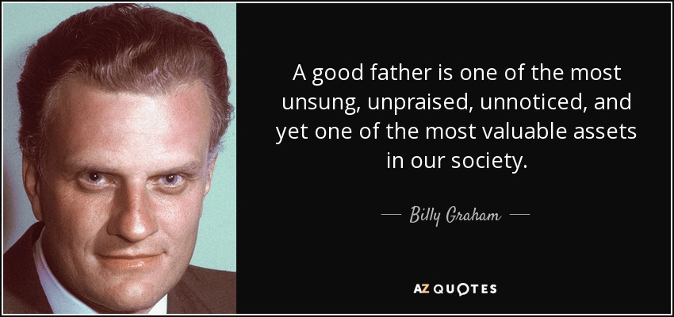

_____________________________________

HAPPY FATHER’S DAY TO

ALL OUR FATHERS!

May your love for Christ and the church be

a beautiful witness to your children as

they grow in their faith and become

difference makers in this world.

God bless you all!

Pat will be working in the office until June 30th – If anyone is interested in doing a bulletin over the summer, please contact her at the office for a short training.
God bless everyone’s efforts.
__________________________________________________________________________________________________________________________________

God often works more by the life of the illiterate seeking the things that are God’s
than by the ability of the learned seeking the things that are their own.
St. Anselm
To have courage for whatever comes in life – everything lies in that
St. Teresa of Avila
_______________________________________________________________________________________________________________________
NEEDED – Cemetery Manager
Thank you to Real Champagne who has been looking after the cemetery for the last 30 years. He is retiring from this responsibility and is asking for someone from the parish to take his place. Real is happy to meet with anyone who might be interested and is willing to go through all the details with them. Please call the office if you are interested and Real can be contacted to meet with you.
PARISH COUNCIL – Tom Stang is retiring from the parish council at the end of June. Thank you so much Tom for all your involvement and work in our parish. You will be missed. We are looking for new members. If you are contemplating it, we encourage you to come to the next parish council meeting to find out more on how the parish functions, etc. We are a very active, dynamic parish and it’s always a pleasure to serve on the committee. Come and see!! Parishioners invited to all mtgs. ______________________________________________________________________________________________________________________

LEAP FOR “FAITH” - If you would like an income tax receipt fror your donation to the “Faith Fund’, Please make the cheque payable to St. Emile Parish and indicate on your cheque that the donation is for “Faith”. At the end of the year your donation to Faith will be included in your yearly tithing Income Tax Receipt. Receipts will be issued for donations until September 30th as granted by the Bishop.
What a gift of sharing for us and for Faith.
Dear church family,
Andre & Natalie Rivard need financial help as they are getting ready to move into the family farmhouse. The house needs many renovations, so it is accessible for Faith, and the costs are overwhelming. Due to Covid-19, the government grants have been depleted and are not an option for them. How exciting it is to help Faith and her amazing family with this huge project. Please visit the gofundme page 'A Leap for Faith.' https://gofund.me/5294fc3c. _______________________________________________________________________________
_______________________________________________________________________________

LITTLE BIT OF HUMOUR: Be thorough!
When you go to confession do not confess that you have stolen a rope and neglect to mention that a cow was attached.
______________________________________________________________________________________________________________________
June 27th - FEAST OF ST. THOMAS MOORE
Thomas More was born in London in 1478. At 18 he was sent to study law and was called to the bar in 1501. 3 years later he entered parliament. An enlightened man, he insisted that his 3 daughters receive the same education as his son. In 1532 Thomas replaced Cardinal Wolsey as Lord Chancellor in court. He resigned 3 years later, openly opposing the king. Thomas also opposed the Protestant Reformation and
Henry III’s separation from the Catholic Church, refusing to acknowledge Henry as supreme head of the Church and the annulment of his marriage. At 57, after refusing to take the oath of Supremacy, he was convicted of treason imprisoned in the Tower of London and eventually beheaded. There he wrote the best of his spiritual works. He always claimed to be “the King’s good servant, but God’s first”. 400 years later Thomas More was declared a saint.

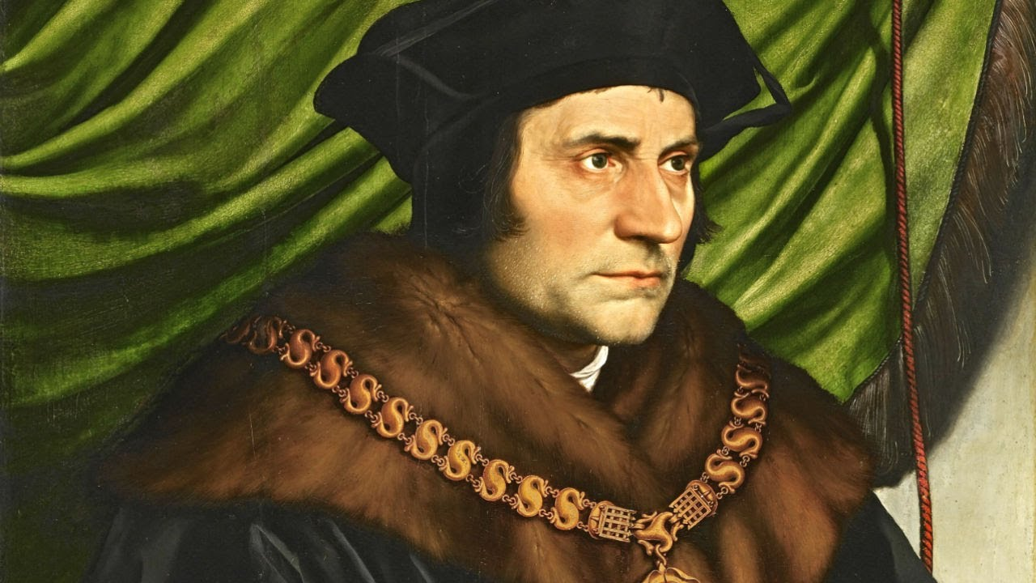

PLEASE SEE NEXT PAGE………

Thank you to Sturgeon Valley Fertilizer for their donation to the parish for spraying at the cemetery. Much appreciated!

Dear Families;
Thank you to everyone who helps keep our cemetery clean. It was suggested that when we go visit the deceased members of our family, to bring our shovel, hoe, lawnmower or weed whackers to trim around the headstones and help keep their plots clean. The maintenance of the cemetery is a big job and every little of help counts. Thank you!

GRANT MONEY RECEIVED – Thank you to Ernie Chauvet who applied for a church grant for the light replacements in the church. The Government of Alberta has issued our parish a cheque for $945.00 We are very greatful Ernie for all your hard work in preparing the Grant and persevering through all the paper work. God bless you! What an amazing parish we have!

